

***Introduction To Database* Project**

**Fall**

**2019-20**



**Project Name: Supershop Database System**

**Course Teacher: DIPTO JUSTINE GOMES**

**Section: [ K ]**

**Group Members**

|  |  |  |  |  |  |  |  |
| --- | --- | --- | --- | --- | --- | --- | --- |
| **Name** |  |  |  |  |  |  |  |
|  |  |  | **ID** |  |  |
|  |  |  |  |  |  |  |  |
| **SHARIAR SIJAN ALVI** | | 19 | | - 40027 | | - 1 | |
|  | |  | |  | |  | |
| **ABIR IBRAHIM BIN MONIR** | | 19 | | - 40418 | | - 1 | |
|  | |  | |  |  |  |  |
| **KAJOL** | | 19 | |  | - 40018 | - | 1 |
|  | |  | |  |  |  |  |

**TABLE OF CONTENTS**

* INTRODUCTON
* E-R DIAGRAM
* NORMALIZATION AND DEPENDENCIES
* CREATING TABLE
* FINAL TABLE LIST
* QUERY QUESTIONS
* SQL COMMANDS
* RELATIONAL ALGEBRA

**INTRODUCTION**

In a super shop, usually people come to shop on either daily basis or weekly. Some may come for monthly shopping. They purchase various kinds of things there.

Customers can buy many products. Customers have name, id, address and contact no. Products have name, id, price and company name. One customer gets one receipt after shopping. Receipt has id, product name, quantity, price and total amount. Employees serve customers. One employee can serve many customers. A employee has id, salary, name, designation and contact no. Products are supplied by many suppliers. Suppliers have name, id, contact no and address. Suppliers take many order lists. Order list has id, supplier id, delivery date, order date and product id. Employee gives order lists.

**ENTITY RELATIONSHIP DIAGRAM**

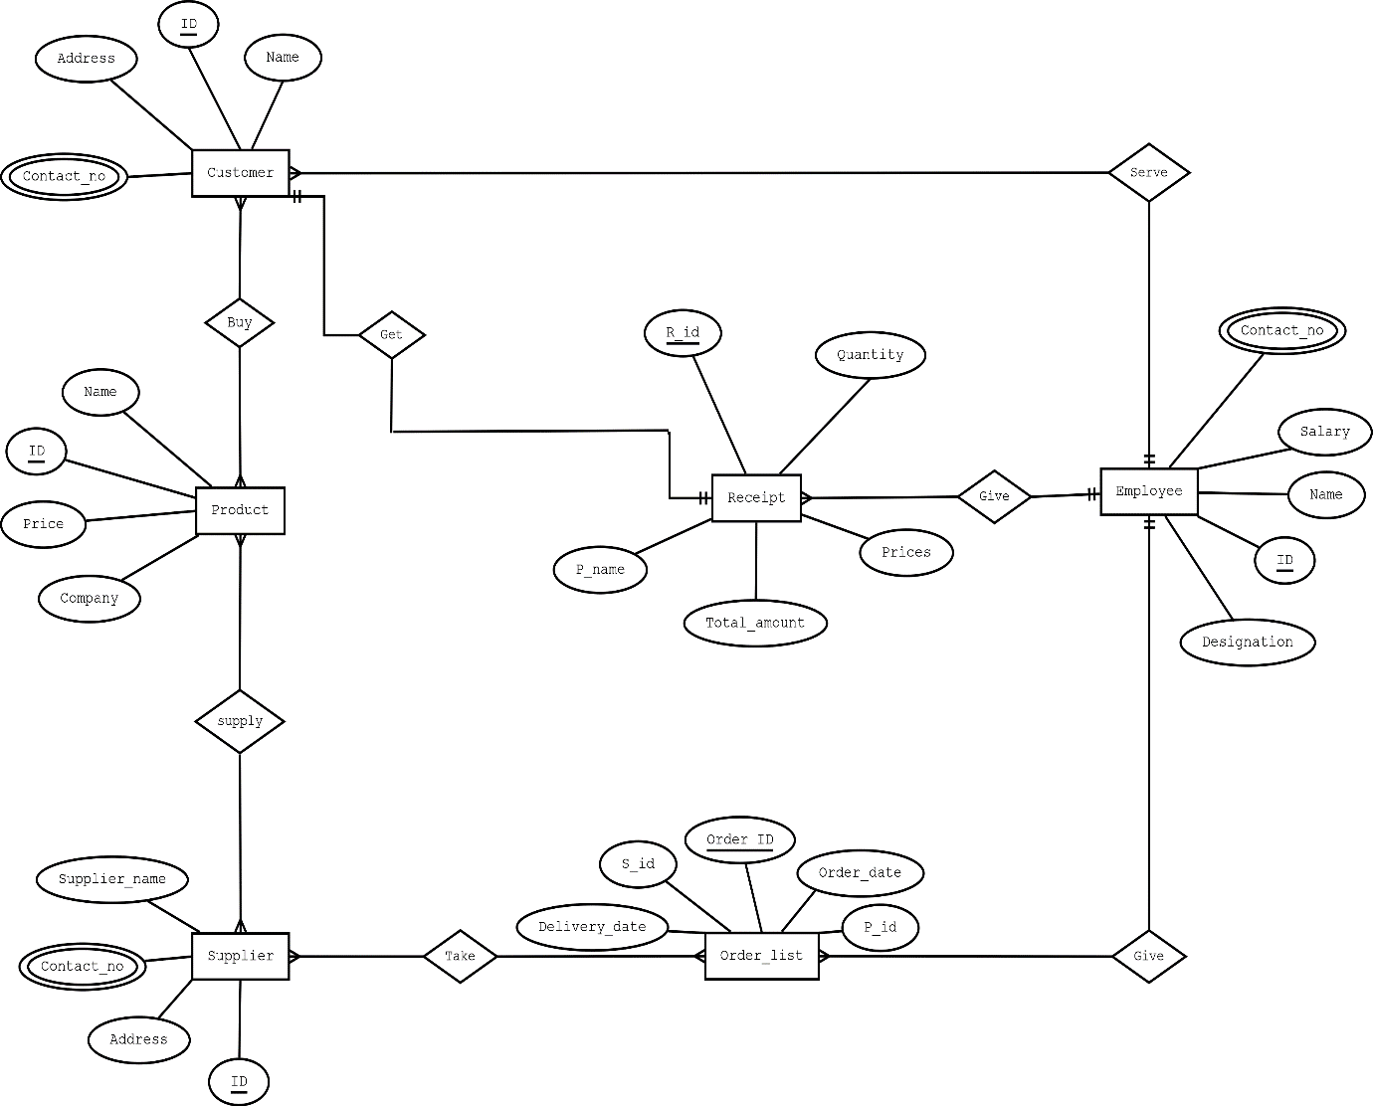

**NORMALIZATION & DEPENDENCIES**

**Buy**: (name,ID,Add,cont no,name,ID,company,price)

1NF → c_contact is a multivalued Attribute

2NF → C_name, C_ID, C_add, C_Contact

P_name, P_ID, company, price

3NF → C_name, C_ID, C_Add, C_Contact

P_name, P_ID, company, price

Table list:

1. C_name, C_ID, C_add
2. P_name, P_ID, company, price
3. B_id, C_ID , P_ID
4. C_id, c_contact

**Supply**: (P_name,P ID, company, price,S_name, S_ID, S_Add, S_contact)

1NF→ S_contact is a multivalued attribute

2NF→ P_name, P_ID, company, price,

S_name, S_ID, s_add, S_contact

3NF→ P_name, P_ID, company, price

S_name, S_ID, S_add, S_contact

Table list:

5. P_name,P_ID, company, price

6. S_name, S_ID, S­_Add, S_contact

7. Sup_ID, p_id , s_id

8. S_id, s_contact

**GET:** (name, id, add, cont,R_id,p_name, quantity, price, total amount)

1NF→ c_contact is a multivalued attribute.

2NF→ c­_name,C_id,C_add,C_contact

R_id, P_name, quantity, price, total_amount

3NF→ c_name, C_id, c_add, C_conatct

R_id,P_name

P2_id, quantity, price, total_amount

TABLE LIST:

9. C_name, C_id, C_add, r_id

10. r_id, p_name, P2_id

11. P2_id, quantity,price, total_amount

12. c_id, c_contact

**TAKE:** (s_name, s_id, s_add, S-contact, O_id,O_date, d_date, P_id,S_id)

1NF→ S_contact is a multivalued attribute

2NF→ s_name, S_id, s_add, s_contact

O_id,O_date, d_date, P_id,S_id

3NF→ o_id, o_date, d_date

Os_id, p_id, s_id

s_name, S_id, s_add, s_contact

TABLE LIST:

13. s_name, s_id, s_add

14. o_id, o_date, d_date, os_id

15. os_id, p_id , s_id

16. t_id, s_id , o_id

17. s_id, s_contact

**SERVE:** (c_name, c_id, c_add, c_contact, e_name, e_id, sal, e_contact, designation)

1NF→ c_contact is a multivaled attribute

E_contact is a multivaled attribute

2NF→ c_name, c_id, c_add, c_contact

e_name, e_id, sal, e_contact, designation

3NF→ c_name, c_id, c_add, c_contact

e_name, e_id, sal, e_contact, designation

TABLE LIST:

18. c_name, c_id, c_add, e_id , R_id

19. e_name, e_id, sal, designation

20. c_id, c_contact

21. e_id, e_conatct

**GIVE**: (e_name, e_id, sal, e_contact, designation, o_id, o_date, d_date, p_id, s_id)

1NF→ e_contact is a multicvalued attribute.

2NF→ e_name, e_id, sal, e_contact, designation

o_id, o_date, d_date, p_id, s_id

3NF→ o_id, o_date, d_date

Os_id, s_id, P_id

e_name, e_id, sal, e_contact, designation

TABLE LIST:

22. o_id, o_date, d_date, os_id , e_id

23. os_id, p_id , s_id

24. e_name, e_id, sal, designation

25. e_id, e_contact

**GIVE:** (R_id, p_name, quantity, price, total_amount, e_name, e_id, sal,e_contact, designation)

1NF→ e_contact is a multivalued attribute

2NF→ R_id, p_name, quantity, price, total_amount

e_name, e_id, sal,e_contact, designation

3NF→ R_id, p_name

P2_id, quantity, price, total_amount

e_name, e_id, sal,e_contact, designation

TABLE LIST**:**

26. r_id, p_name, P2_id , e_id

27. P2_id, quantity, price, total_amount

28. e_name, e_id, sal, designaton

29. e_id, e_contact

**CREATING TABLE**

Create user Project identified by oracle;

grant connect, resource, unlimited tablespace to Project;

ALTER USER Project DEFAULT TABLESPACE USERS;

ALTER USER Project TEMPORARY TABLESPACE TEMP;

FINAL TABLES

1.CUSTOMER:

Create table customer(

C_name varchar2 (20),

C_id number (6),

C_add varchar2 (25),

R_id number ( 6),

E_id number (6))

Alter table customer add constraint c1 primary key (C_id)

Alter table customer add constraint c2 foreign key(R_id) references receipt(R_id)

Alter table customer add constraint c3 foreign key(E_id) references emp(E_id)

Insert into customer values(‘Abir’,100000,’Mirpur’,100000,100000)

Insert into customer values(‘Jakir’,100001,’Sahajadpur’,100001,100001)

Insert into customer values(‘Aryan’,100002,’Purobi’,100002,100002)

2.PRODUCT:

Create table product(

P_name varchar2 (20),

P_id number (6),

Company varchar2 (15),

Price number(6))

Alter table product add constraint p1 primary key(p_id)

Insert into product values(‘Fish’,100000,’Bengal’,550)

Insert into product values(‘Rice’,100001,’Dada’,65)

Insert into product values(‘Soap’,100002,’LUX’,55)

3.CP:

Create table cp(

B_id number(6),

C_id number (6),

P_id number(6))

Alter table cp add constraint cp1 primary key(B_id)

Alter table cp add constraint cp2 foreign key(C_id) references customer(C_id)

Alter table cp add constraint cp3 foreign key(P_id) references product(P_id)

Insert into cp values(100000,100000,100000)

Insert into cp values(100001,100001,100001)

Insert into cp values(100002,100002,100002)

4.CUST:

Create table cust(

C_id number (6),

C_contact number (11))

Alter table cust add constraint cu1 primary key (c_contact)

Insert into cust values(100000,01111111110)

Insert into cust values(100001,01111111111)

Insert into cust values(100002,01111111112)

5.SUPPLIER:

Create table supplier(

S_name varchar2 (20),

S_id number (6),

S_add varchar2 (20))

Alter table supplier add constraint s1 primary key (S_id)

Insert into supplier values(‘Rakib’,100000,’New Market’)

Insert into supplier values(‘Jaman’,100001,’Old Dhaka’)

6.SUPP:

Create table supp(

Sup_id number (6),

S_id number(6),

P_id number(6))

Alter table supp add constraint sup1 primary key (Sup_id)

Alter table supp add constraint sup2 foreign key(P_id) references product(P_id)

Alter table supp add constraint sup3 foreign key(S_id) references supplier(S_id)

Insert into supp values(100000,100000,100000)

Insert into supp values(100001,100001,100001)

Insert into supp values(100002,100001,100002)

7.SUPP2:

Create table supp2(

S_id number (6),

S_contact number (11))

Alter table supp2 add constraint supp1 primary key (S_contact)

Insert into supp2 values(100000,01211111110)

Insert into supp2 values(100000,01211111111)

Insert into supp2 values(100001,01211111112)

8.RECEIPT:

Create table receipt(

R_id number (6),

P_name varchar2 (20),

P2_id number (6),

E_id number (6))

Alter table receipt add constraint r1 primary key (R_id)

Alter table receipt add constraint r2 foreign key(P2_id) references pro(P2_id)

Alter table receipt add constraint r3 foreign key(E_id) references emp(E_id)

Insert into receipt values(100000,’Fish’,100000,100000)

Insert into receipt values(100001,’Rice’,100001,100001)

Insert into receipt values(100002,’Soap’,100002,100002)

9.PRO:

Create table pro(

P2_id number (6),

Quantity number (10),

Price number (6),

Total_amount number (6))

Alter table pro add constraint pro1 primary key (P2_id)

Insert into pro values(100000,2,550,1100)

Insert into pro values(100001,2,65,120)

Insert into pro values(100002,1,55,55)

10.ORDER_LIST:

Create table order_list(

O_id number (6),

O_date date,

D_date date,

Os_id number (6),

E_id number (6))

Alter table order_list add constraint o1 primary key (O_id)

Alter table order_list add constraint o2 foreign key(Os_id) references os(Os_id)

Alter table order_list add constraint o3 foreign key(E_id) references emp(E_id)

Insert into order_list values(100000,’08-DEC-2019’,’10-DEC-2019’,100000,100000)

Insert into order_list values(100001,’09-DEC-2019’,’10-DEC-2019’,100000,100000)

11.OS:

Create table os(

Os_id number (6),

P_id number (6),

S_id number(6))

Alter table os add constraint os1 primary key (Os_id)

Alter table os add constraint os2 foreign key(P_id) references product(P_id)

Alter table os add constraint os3 foreign key(S_id) references supplier(S_id)

Insert into os values(100000,100000,100000)

Insert into os values(100001,100001,100001)

12.ORD:

Create table ord(

T_id number (6),

S_id number (6),

O_id number (6))

Alter table ord add constraint or1 primary key (T_id)

Alter table ord add constraint or2 foreign key(S_id) references supplier(S_id)

Alter table ord add constraint or3 foreign key(O_id) references order_list(O_id)

Insert into ord values(100000,100000,100000)

Insert into ord values(100001,100000,100001)

13.EMP:

Create table emp(

E_name varchar2 (20),

E_id number (6),

Sal number (6),

Designation varchar2(20))

Alter table emp add constraint e1 primary key (E_id)

Insert into emp values(‘Binti’,100000,80000,’Manager’)

Insert into emp values(‘Atik’,100001,20000,’Salesman’)

Insert into emp values(‘Tazkia’,100002,55000,’Supervisor’)

14.EMP2:

Create table emp2(

E_id number (6),

E_contact number (6))

Alter table emp2 add constraint emp1 primary key (E_contact)

Insert into emp2 values(100000,013110)

Insert into emp2 values(100000,013111)

Insert into emp2 values(100001,013112)

Insert into emp2 values(100002,013113)

**FINAL TABLE LIST**

|  |  |  |
| --- | --- | --- |
| TABLE NO | TABLE NAME | COLUMN NAME |
| 1 | customer | C_name, C_id, C_add, R_id , E_id |
| 2 | product | P_name, P_id, Company, Price |
| 3 | cp | B_id, C_id , P_id |
| 4 | cust | C_ id, C_contact |
| 5 | supplier | S_name, S_id, S_add |
| 6 | supp | Sup_id, P_id , S_id |
| 7 | supp2 | S_id, S_contact |
| 8 | receipt | R_id, P_name, P2_id , E_id |
| 9 | pro | P2_id, Quantity, Price, total_amount |
| 10 | order_list | O_id, O_date, D_date, Os_id , E_id |
| 11 | os | Os_id, P_id , S_id |
| 12 | ord | T_id, S_id , O_id |
| 13 | emp | E_name, E_id, Sal, Designation |
| 14 | emp2 | E_id, E_contact |

**Query**

1. Find all the information of the customer who lives in Mirpur.
2. Find name and salary of the employees who sold fish.
3. Find name and id of the employee who gets minimum salary.
4. Create a view customer_info based on customers’ name, id and contact no.
5. Create a sequence for customer where customer id is 100006 to 100050 and increases by 1. Then alter the sequence where max id limit is 100090.
6. Display product name, company name and supplier name in one table where Jaman is the supplier.
7. Display all employee data who served Abir.
8. Display average salary of all the employees.
9. Rename employee sal to salary.
10. Display all constraints.

**SQL**

* Find all the information of the customer who lives in Mirpur.

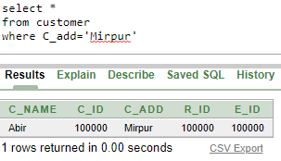

* Find name and salary of the employees who sold fish.

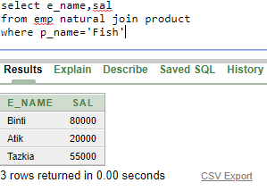

* Find name and id of the employee who gets minimum salary.

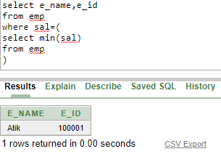

* Create a view customer_info based on customers’ name, id and contact no.

create view customer_info as

select c_name, c_id

from customer

* Create a sequence for customer where customer id is 100006 to 100050 and increases by 1. Then alter the sequence where max id limit is 100090.

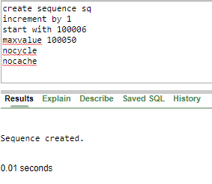

//Alter sequence

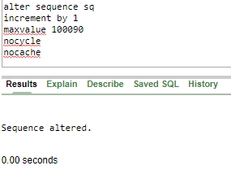

* Display product name, company name and supplier name in one table where Jaman is the supplier.

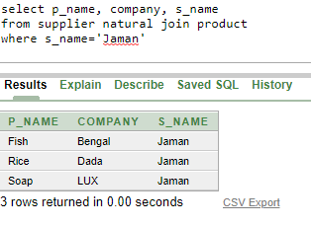

* Display all employee data who served Abir.

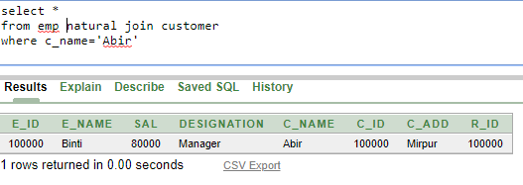

* Display average salary of all the employees.

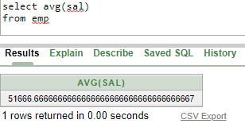

* Rename employee sal to salary.

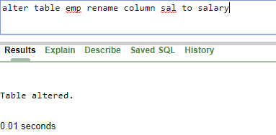

* Display all constraints.

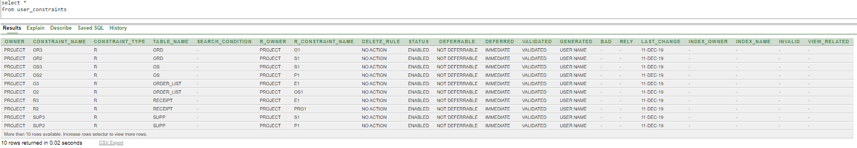

**RELATIONAL ALGEBRA**

* Find all the information of the customer who lives in Mirpur.

*σ* *c_add=”Mirpur”* (customer)

* Find name and salary of the employees who sold fish.

. ∏*e_name, sal* (*σ* *p_name =”Fish”* (emp ⋈ product))

* Find name and id of the employee who gets minimum salary.

∏ *e*_*name,e_id*(*σ* *salr=min(sal)* (emp))

* Display product name, company name and supplier name in one

table where Jaman is the supplier.

∏ *p_name,company,s_name*(σ *s_name=“Jaman”* (supplier ⋈ product))

* Display all employee data who served Abir.

*σ* *p_name=“Abir”* (emp ⋈ product)

* Display average salary of all the employees.

∏ *avg(sal)*(*σ* (emp))

* Rename employee sal to salary.

*ρsal/salary*(emp)

* Display all constraints.

*σ* (user_constraints)

**THE END**